|  |
| --- |
| Professional Readiness for  **INNOVATION,EMPLOYABILITY**  **AND ENTREPRENEURSHIP** |

***SMART HOME***

**SUBMITTED BY**

**J.R.SUMI**

**961819106054**

**B12-6A2E**

**MOTION DETECTION USING IR SENSOR:**

**CODE:**

int pirsensor =0;

void setup()

{

pinMode(2, INPUT);

pinMode(12, OUTPUT);

pinMode(13, OUTPUT);

}

void loop()

{

pirsensor = digitalRead(2);

if(pirsensor == HIGH)

{

//glow led

digitalWrite(13,HIGH);

// ring buzzer

tone(12,500,500);

}

digitalWrite(13,LOW);

}

**TINKERCAD LINK:**

[**https://www.tinkercad.com/things/j2zPoq33n0T**](https://www.tinkercad.com/things/j2zPoq33n0T)

**FIGURE:**

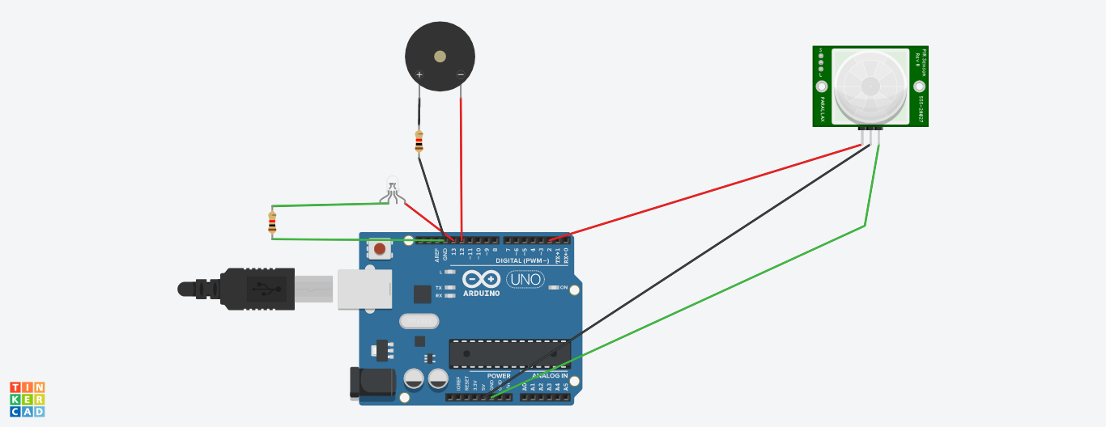

Whenever  anyone comes in the path or  range of IR sensor, microcontroller detects the distance of object from the sensor and if the object is in the defined range  it sends the High signal to buzzer and buzzer starts  beeping at the same time light is emitting.